Mixed (Between, Within) ANOVA
With a Continuous Predictor Included in the Model

I have helped my colleague, Erik Everhart, with ANOVA where there are categorical predictors (including within-subjects predictors) and a continuous predictor and where it is desired that the model include all interactions, including those between the categorical predictors and the continuous predictor. Here is an example of the SAS code used to conduct such an analysis:

proc glm; class valence;
model BLF4A1 BLF8A1 BLT4A1 BLT6A1 BLC4A1 BLP4A1 BL02A1
VLF4A1 VLF8A1 VLT4A1 VLT6A1 VLC4A1 VLP4A1 VL02A1
XLF4A1 XLF8A1 XLT4A1 XLT6A1 XLC4A1 XLP4A1 XL02A1
YLF4A1 YLF8A1 YLT4A1 YLT6A1 YLC4A1 YLP4A1 YL02A1
= CMHI|valence / nouni; repeated trial 4, site 7; title 'right hemisphere - CMHI'; run;

Trial and site are the repeated factors, valence the between-subjects factor, and CMHI the continuous predictor. Fifteen F ratios are produced by this analysis. Here is a bit of the output.
MANOVA Test Criteria and Exact F Statistics for the Hypothesis of no site*CMHI*VALENCE Effect
H = Type III SSCP Matrix for site*CMHI*VALENCE
E = Error SSCP Matrix

S=1 M=2 N=18

Statistic Value F Value Num DF Den DF Pr > F

Wilks' Lambda 0.71155193 2.57 6 38 0.0347
Pillai's Trace 0.28844807 2.57 6 38 0.0347
Hotelling-Lawley Trace 0.40537880 2.57 6 38 0.0347
Roy's Greatest Root 0.40537880 2.57 6 38 0.0347

Source DF Type III SS Mean Square F Value Pr > F G - G H - F

site 6 6.56978865 1.09496478 14.96 <.0001 <.0001 <.0001
site*CMHI 6 0.50149394 0.08358232 1.14 0.3385 0.3329 0.3357
site*VALENCE 6 1.76673999 0.29445666 4.02 0.0007 0.0113 0.0079
site*CMHI*VALENCE 6 1.59292272 0.26548712 3.63 0.0018 0.0180 0.0134
Error(site) 258 18.88707111 0.07320570

Erik figured out how to do this analysis in SPSS. Analyze, General Linear Model, Repeated Measures. Define the within-subjects factors (a real pain), and identify the continuous predictor as a “covariate.”

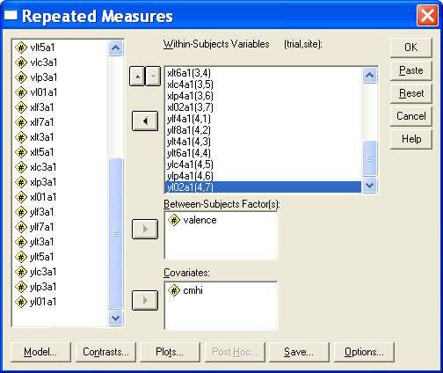

Click Model, select custom, and build the model as illustrated below.

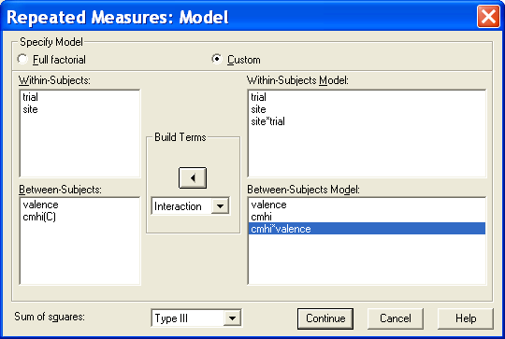
Continue OK. The analysis is identical to that produced by SAS. Here is some of the output.

Multivariate Tests(b)

site * valence * cmhi | Pillai's Trace | .288 | 2.567(a) | 6.000 | 38.000 | .035
site * valence * cmhi | Wilks' Lambda | .712 | 2.567(a) | 6.000 | 38.000 | .035
site * valence * cmhi | Hotelling's Trace | .405 | 2.567(a) | 6.000 | 38.000 | .035
site * valence * cmhi | Roy's Largest Root | .405 | 2.567(a) | 6.000 | 38.000 | .035

Tests of Within-Subjects Effects

Measure: MEASURE_1
Source |  | Type III Sum of Squares | df | Mean Square | F | Sig.
site * valence * cmhi | Sphericity Assumed | 1.593 | 6 | .265 | 3.627 | .002
site * valence * cmhi | Greenhouse-Geisser | 1.593 | 2.735 | .582 | 3.627 | .018
site * valence * cmhi | Huynh-Feldt | 1.593 | 3.143 | .507 | 3.627 | .013
site * valence * cmhi | Lower-bound | 1.593 | 1.000 | 1.593 | 3.627 | .064

Here is the syntax:
GLM
blf4a1 blf8a1 blt4a1 blt6a1 blc4a1 blp4a1 bl02a1 vlf4a1 vlf8a1 vlt4a1 vlt6a1 vlc4a1 vlp4a1 vl02a1 xlf4a1 xlf8a1 xlt4a1
xlt6a1 xlc4a1 xlp4a1 xl02a1 ylf4a1 ylf8a1 ylt4a1 ylt6a1 ylc4a1 ylp4a1 yl02a1 BY valence WITH cmhi
/WSFACTOR = trial 4 Polynomial site 7 Polynomial
/METHOD = SSTYPE(3)
/CRITERIA = ALPHA(.05)
/WSDESIGN = trial site site*trial
/DESIGN = valence cmhi cmhi*valence .

Karl L. Wuensch, Dept. of Psychology, East Carolina University, Greenville, NC
July, 2006

Return to Wuensch’s Stats Lessons Page

